Specialist Mathematics Units 3 & 4
Test 3 2018
Calculator Free Section

Name: __________________________ Score: _____ / 22
Time Allowed: 20 minutes
No calculators or notes are to be used.
Access to approved Mathematics Specialist formulae sheet is permitted.
Where a question or part of a question is worth more than 2 marks sufficient working to justify your solution is required
1. [ 4 marks ]
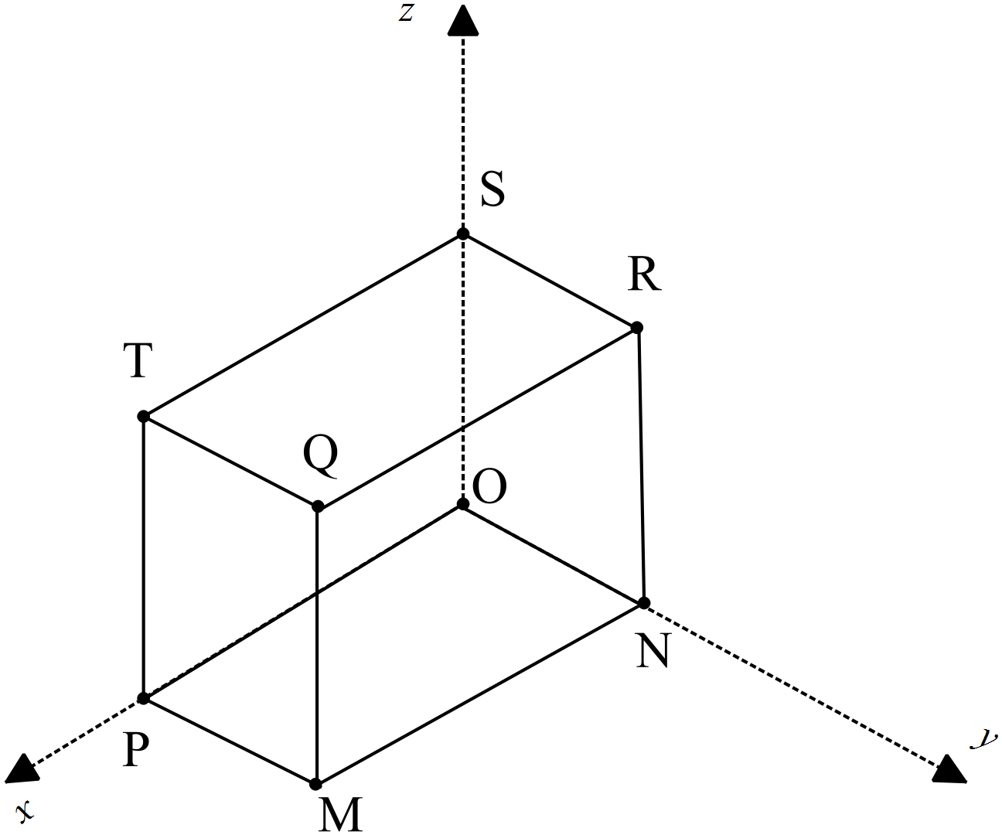MNOPQRST is a rectangular prism with OP = p, ON = n and OS = s.
O is the origin of the x-y-z axes.
Use the fact that $a×b=\left|a\right|\left|b\right|sinθ$ and $a.b= \left|a\right|\left|b\right|cosθ$to prove that the volume of the cuboid is $\left|\left(p×n\right).s\right|$

The area of the base is $\left|p×n\right|$ because it equals $\left|p\right|\left|n\right|×1$ since p and n are perpendicular and $sin{90}^{°}$ =1
The height is $\left|s\right|$ , therefore the volume is $\left|p×n\right|\left|s\right|$
p×n and $s$ are parallel so
$\left|cos0°\right|$or$\left|cos180°\right|$ = $\frac{\left|\left(p×n\right).s\right| }{\left|p×n\right|\left|s\right|}=1$
Therefore $\left|\left(p×n\right).s\right|=\left|p×n\right|\left|s\right|=$volume of the cuboid

2. [ 5,1 = 6 marks]
A plane Γ contains the points P at position k – 2j, Q at 4i + j +3k and R at 2k – i.
a) Determine a vector equation which contains the normal to the plane.
PR = $\left[\begin{matrix}-1 \\ 0 \\ 2\end{matrix}\right]-\left[\begin{matrix}0 \\ -2 \\ 1\end{matrix}\right]$ = $\left[\begin{matrix}-1 \\ 2 \\ 1\end{matrix}\right]$

PQ = $\left[\begin{matrix}4 \\ 1 \\ 3\end{matrix}\right]-\left[\begin{matrix}0 \\ -2 \\ 1\end{matrix}\right]$ = $\left[\begin{matrix}4 \\ 3 \\ 2\end{matrix}\right]$ or QR = $\left[\begin{matrix}-1 \\ 0 \\ 2\end{matrix}\right]-\left[\begin{matrix}4 \\ 1 \\ 3\end{matrix}\right]$ = $\left[\begin{matrix}-5 \\ -1 \\ -1\end{matrix}\right]$

PR $×PQ =$ $\left[\begin{matrix}-1 \\ 2 \\ 1\end{matrix}\right]×\left[\begin{matrix}4 \\ 3 \\ 2\end{matrix}\right]$

= $\left[\begin{matrix}4-3 \\ -(-2-4) \\ -3-8\end{matrix}\right]$

= $\left[\begin{matrix}1 \\ 6 \\ -11\end{matrix}\right]$ (-1 each mistake)
Using P, r.n = $\left[\begin{matrix}0 \\ -2 \\ 1\end{matrix}\right]. \left[\begin{matrix}1 \\ 6 \\ -11\end{matrix}\right]$ = -23
So r. $\left[\begin{matrix}1 \\ 6 \\ -11\end{matrix}\right]= -23$

b) Express this as a Cartesian equation.
x + 6y - 11z = -23 or x + 6y - 11z + 23 = 0

3. [1, 1, 3 = 5 marks ]
A point P moves in a path according to the parametric equations: $x=2\cos{t}, y=3\sin{t , }$ where $t≥0$
- Give the Cartesian equation of the path
$\frac{x^{2}}{4}+\frac{y^{2}}{9}=$ $\frac{{(2\cos{t}}^{)2}}{4}+\frac{({3\sin{t) }}^{2}}{9}= \cos{t^{2}+ \sin{t^{2}}{=1}}$
So $\frac{x^{2}}{4}+\frac{y^{2}}{9}=1$
- State the velocity vector of the ellipse
$v=\left[\begin{matrix}-2\sin{t} \\ 3\cos{t}\end{matrix}\right]$

- Draw the path traced by P, indicating its direction clearly and key points
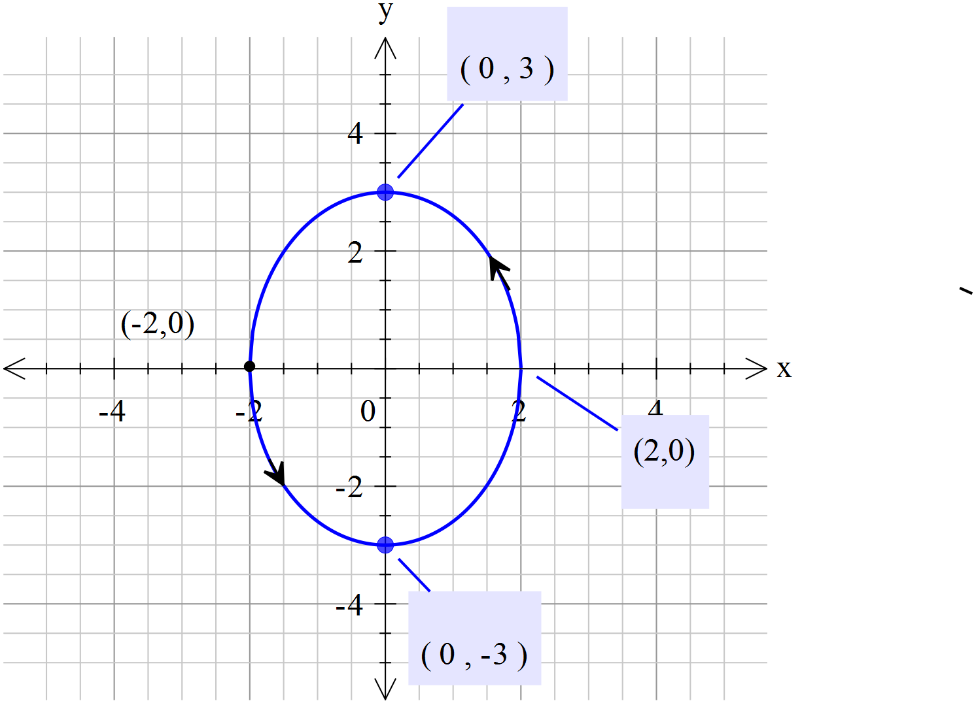

Shape of path
Direction correct
Scale/points shown

4. [4, 1, 2 = 7 marks]
x | + | 3y | - | z | = | 5
2x | + | 7y | - | 3z | = | 6
-x | - | y | + | (p²-p-1)z | = | p-13
For what value of p will the above system of equations have
- an infinite number of solutions,
An infinite number of solutions when p = 0
- no solutions
No solution when p = 1
- a unique solution?
A unique solution when pand p

Specialist Mathematics Units 3 & 4
Test 3 2018
Calculator Assumed Section

Name: _______________________ Score: _____ / 25
Time Allowed: 25 minutes
Materials Allowed: SCSA formula booklet, SCSA approved calculators and one A4 page of notes (both sides).
Instructions: Where a question or part of a question is worth more than 2 marks sufficient working to justify your solution is required.

5. [1,1,3 ,4 = 9 marks ]
The Cartesian equation of plane ∏ is .
a) State a vector equation of this plane.

A correct vector equation (many are possible but only one is obvious)

The parametric equations of line are .
b) State a vector equation for line .

A correct vector equation (many are possible but only one is obvious)

c) Determine the position vector of , the point of intersection of line and the plane.

Substitutes expression for r in equation of line into equation of plane.
Solves for $λ$ =-4
Correct position vector for A

d) Determine the angle between Line L and plane ∏
cos Θ = $\left[\begin{matrix}2 \\ -1 \\ \end{matrix}\right].$

d) Determine the acute angle $α$ between Line L and plane ∏ to the nearest tenth of a degree.
cos Θ = $\frac{\left[\begin{matrix}2 \\ -1 \\ 1\end{matrix}\right].\left[\begin{matrix}1 \\ 2 \\ -1\end{matrix}\right]}{\left|\left|\begin{matrix}2 \\ -1 \\ 1\end{matrix}\right|×\left|\begin{matrix}1 \\ 2 \\ -1\end{matrix}\right|\right|}$
$α$= 180 - $\cos^{-1}\left(\frac{-1}{5.916}\right)$

$α$ = 99.6$°$ , acute version is 80.4 $°$
so angle at plane is 9.6 $°$. Alternatively or $α$ = $\sin^{-1}\left(\frac{-1}{5.916}\right)$ = 9.6 $°$.
Uses dot product formula to give an expression for the supplementary angle.
Uses inverse of trig ratio to find angle
Adjusts for acute angle (or uses sin of dot product )
Correct angle for $α$

6. [ 5, 2, 2, 3, 2 = 12 marks]
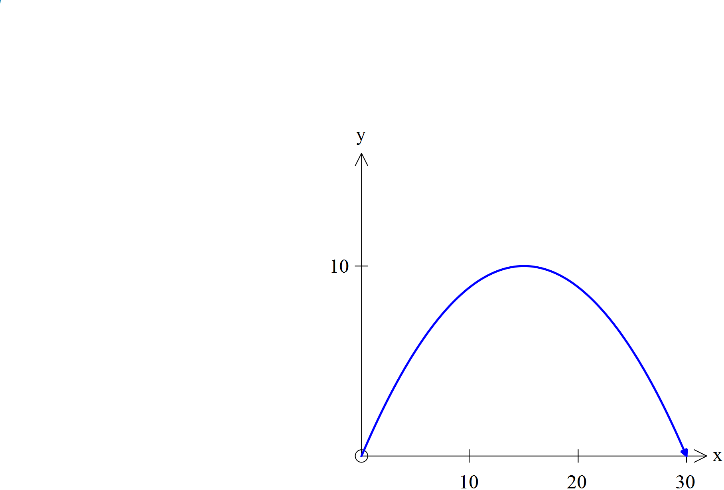For a particle projected from the Origin with speed µ ms⁻¹ at an angle of $Θ$ $0<θ^{°} <90)$ with the positive x-axis, the position vector at time $t$seconds is $r\left(t\right)=ucosθti+\left(usinθt-5t^{2}\right)j$ metres. The equation of the path of the particle is given by

$y=xtanθ-\left[\frac{5(1+\tan^{2}θ}{u^{2}}\right]x^{2}$

The diagram featured shows the path of the particle.

The equation of the path of P is $=\frac{4x}{3}-\frac{2x^{2}}{45}$ .

a) State the position vector of P at time $t$ seconds.

Comparing the two equations:
$xtanθ=\frac{4x}{3}$

So $tanθ=\frac{4}{3}$ also sin$θ$=$\frac{4}{5}$ and cos$θ$=$\frac{3}{5}$

Also [(5(1+(${\frac{4}{3})}^{2}$/$u^{2}$]$=\frac{2}{45}$

Therefore $u=±\frac{25\sqrt{2}}{2}$ , using calculator

So $r\left(t\right)=<\left(\frac{25\sqrt{2}}{2}×\frac{3}{5}\right)t,\frac{25\sqrt{2}}{2}×\frac{4}{5}t-5t^{2}>$

$r\left(t\right)=<\left(\frac{15\sqrt{2}}{2}\right)t,10\sqrt{2}t-5t^{2}>$

b) Use vector methods to find the direction of the particle at time $t=1$seconds .

$v\left(t\right)=<\left(\frac{15\sqrt{2}}{2}\right),10\sqrt{2}-10t>$

$v\left(t1\right)=<\left(\frac{15\sqrt{2}}{2}\right),10\sqrt{2}-10>$

$\tan^{-1}\left(\frac{10\sqrt{2}-10}{15\sqrt{2}÷2}\right)$ = 21.33185286$°$ or 0.3723110679 radians

c) Use vector methods to find the distance travelled by P along its path, from the time of the projection to the time it hits the $x$-axis again. Show clearly how you obtained your answer.

When it hits the ground $10\sqrt{2}t-5t^{2}=0$
Therefore $t=2\sqrt{2}$ seconds as $t≥0$
Distance along path is $\int_{0}^{2\sqrt{2}}{norm\left(\left[\begin{matrix}15\sqrt{2} \\ 10\sqrt{2}-10t\end{matrix}\right]\right)dt}$

= 37.35938825 metres

7. [ 4 marks ]
Prove that the line r =$〈3,0,2〉+λ〈2,2,-1〉$ is a tangent to the sphere with equation (x-2)²+(y-1)²+(z+1)² = $10$
Change sphere formula to vector equation $\left|r-\left[\begin{matrix}2 \\ 1 \\ -1\end{matrix}\right]\right|=\sqrt{10}$
Substitute $\left[\begin{matrix}2λ+3 \\ 2λ \\ 2-λ\end{matrix}\right]$ into $\left|r-\left[\begin{matrix}2 \\ 1 \\ -1\end{matrix}\right]\right|=\sqrt{10}$
Giving $\left|\left[\begin{matrix}2λ+1 \\ 2λ-1 \\ 3-λ\end{matrix}\right]\right|=\sqrt{10}$

Solving ${(2λ+1)}^{2}+{(2λ-1)}^{2}+{(3-λ)}^{2}=10$
Gives $λ=\frac{1}{3}$
Since there is only one point where the line touches the sphere it is a tangent.

8. [ 2,2,2,2= 8 marks ]
Three particles A, B & C are such that their initial positions relative to the Origin at a given time are < 0, -1, -2> m ; < 4, 1, 6 > m and < -4, 1, -2> m respectively. Their constant velocities are < 1, 2, 2 >ms⁻¹, < -1, α, -2 > ms⁻¹ and < 3, 1, β >ms⁻¹ , also respectively.
a) State the position vectors of each particle after t seconds
OA = $\left[\begin{matrix}0 \\ -1 \\ -2\end{matrix}\right]$+t$\left[\begin{matrix}1 \\ 2 \\ 2\end{matrix}\right]$ OB = $\left[\begin{matrix}4 \\ 1 \\ 6\end{matrix}\right]$+t$\left[\begin{matrix}-1 \\ α \\ -2\end{matrix}\right]$ OC = $\left[\begin{matrix}-4 \\ 1 \\ -2\end{matrix}\right]$+t$\left[\begin{matrix}3 \\ 1 \\ β\end{matrix}\right]$ (-1 each mistake)
or
OA = $\left[\begin{matrix}t \\ 2t-1 \\ 2t-2\end{matrix}\right]$ OB = $\left[\begin{matrix}4-t \\ αt+1 \\ -2t+6\end{matrix}\right]$ OC =$\left[\begin{matrix}-4+3t \\ t+1 \\ βt-2\end{matrix}\right]$
b) If these velocities are maintained all three will collide. Use vector methods to determine the values of α and β.
Comparing i components , t = 4-t = 3t-4 giving t = 2
Comparing j components , 2t+1 = $αt$+1 = t + 1
When t = 2, α = 1
Comparing k components , 2t -2 = 6 – 2t = $βt-2$
When t = 2, $β$= 2

c) If these velocities are maintained only A and B will collide. Use vector methods to determine the possible values of α and β in this instance.
A, B & C collide at t = 2 seconds for α = 1 and $β$= 2
For A & B to collide t = 2 and α = 1
For C not to collide with them $β≠2$

d) If these velocities are maintained only two of the three will collide. Use vector methods to determine the possible values of α and β in this instance.
For two only to collide α = 1 or $β$= 2, since when both are true all three collide. If neither are true ie α $≠$ 1 and $β≠$ 2 , no collision will occur

